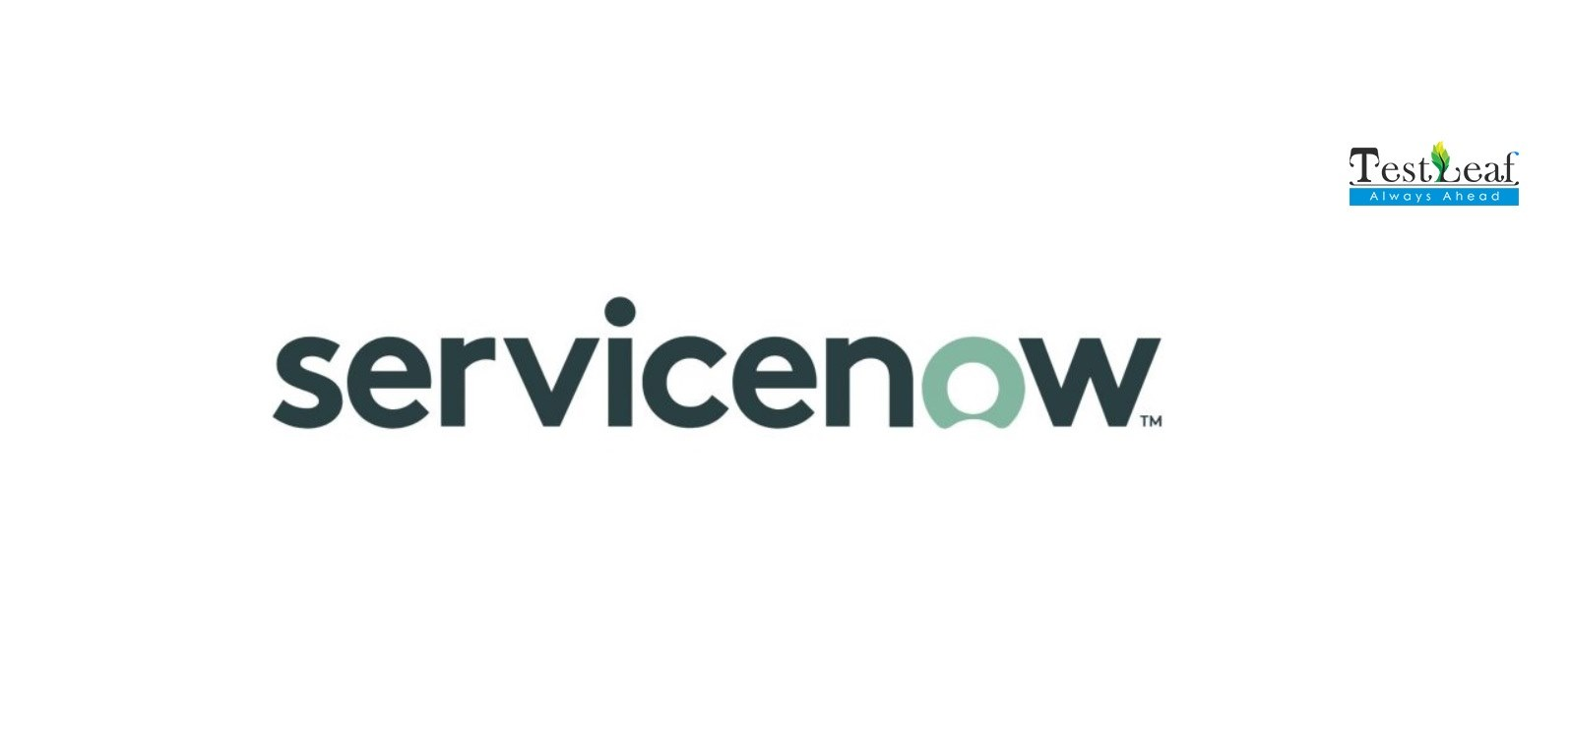

ServiceNow Instance Setup

Steps to create ServiceNow developer account

**Note:** Create an account if you do not already have one

1. In a web browser, navigate to <https://developer.servicenow.com/>
2. Log in to your account
3. Using the navigation, go to **Manage > Instance**
4. On the My Instance page, click the **Request Instance** button
5. Click a version to request an instance with that version
6. When your new instance is displayed, make note of the Username and Password provided
7. Click the instance URL link to open your Personal Developer Instance (Ex: dev8675309.servicenow.com)
8. Login to your Personal Developer Instance with the Username and Password from Step 6
9. From the Change Password prompt, change your admin password

**Congratulations! You now have your very own Personal Developer Instance!**